**AWS SETUP**

1. **Make sure to have an AWS account**
2. **Create a user with MFA and Admin access**
3. **Set Billing Alarm**

**Go to CLOUDWATCH --🡪 In Alarm -🡪 Create alarm**

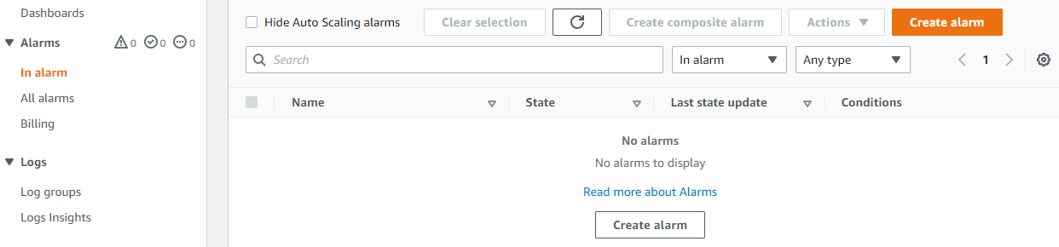

**Make sure to have Billing at the bottom, if not got to next step first**

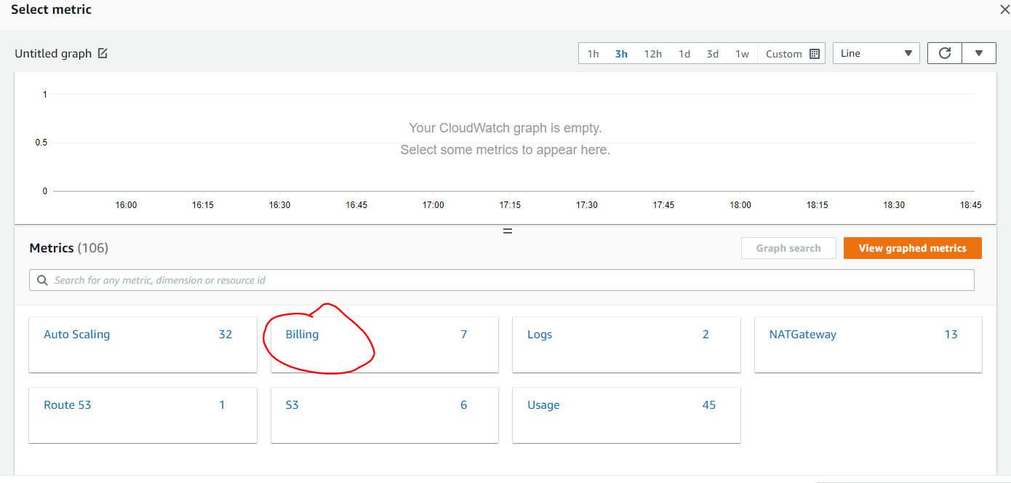

**Go to Billing as root --🡪 Then Billing preferences, select all.**

**Then go back to previous billing to set the alarm.**

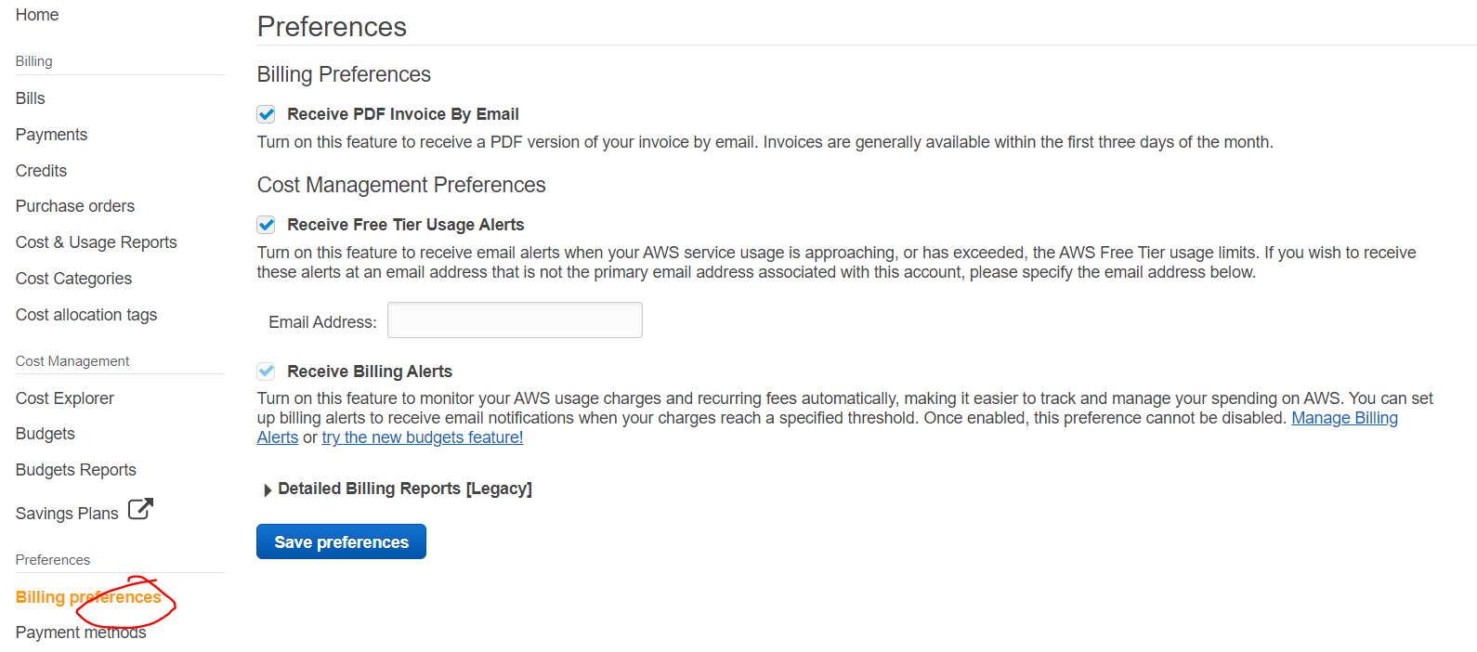

**Go to ACM to request Public Cert**

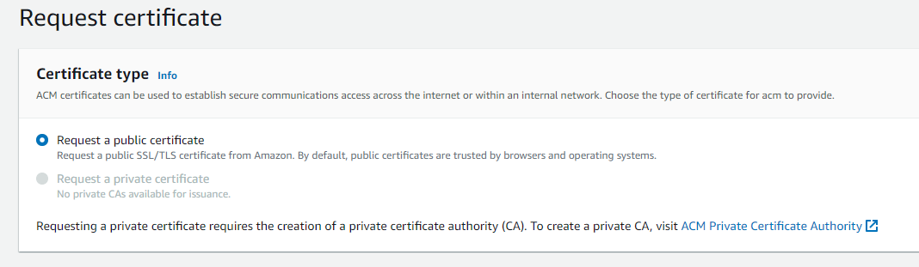

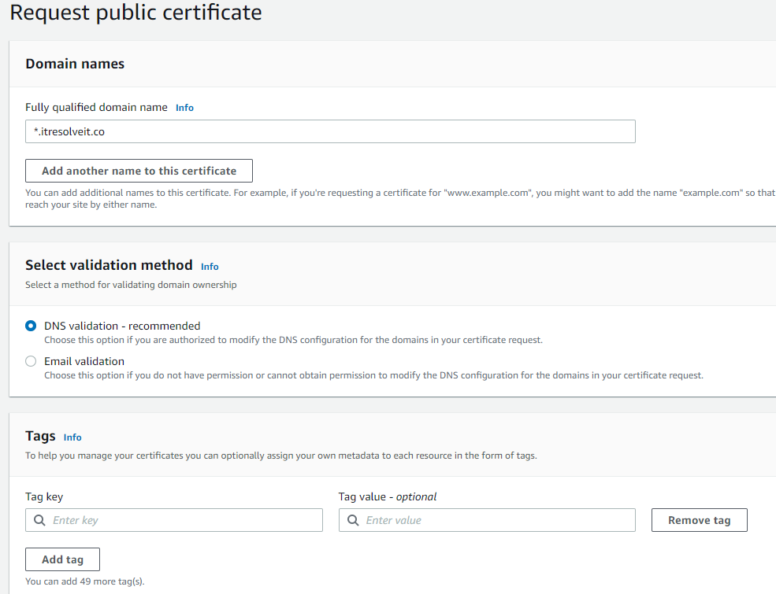

**Go to your GODADDY to add this DNS record: CNAME name and CNAME value.**

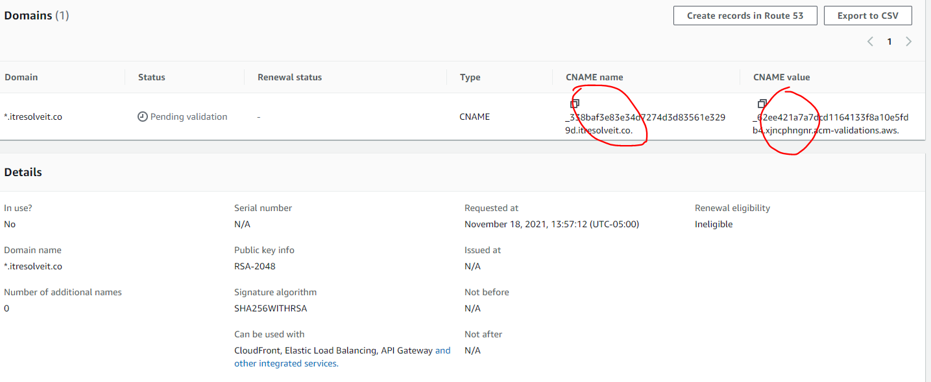

**In the few minutes to hour, it will be issued.**

